Chapter 9, Solution 21.

(a)

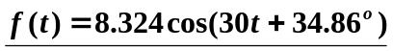

(b)

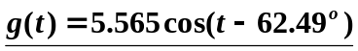

(c) 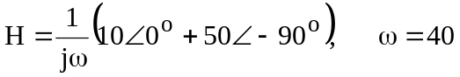
i.e.

h(t) = 1.2748cos(40t – 168.69°)

